

SportCoaching Australia vs Local Running Clubs: Which Training Option Delivers Better Results?
Then, when you begin running, it may seem that you are at a crossroads. On the one hand, there is the frenzy of local running clubs, with chatter, giggles, and group runs. Conversely, the dedicated, personalised strategy of employing a private running coach provides a more personalised direction.
Being a runner in Australia, these two options can not only determine your speed, but also your experience, confidence and performance. You may be running your first 5K or training to run a marathon, but it is important to know the differences.
SportCoaching Australia has gained credibility among runners who require specialised training and professional trainers. They are a good substitute to traditional club training because they combine professional training, formalised plans and performance monitoring. Therefore, we can deconstruct what each approach provides and how to choose the most suitable one.

What a Local Running Club Offers
With a running club, one usually feels as though they are entering a small society. On the initial morning run, you have runners of all levels, who share stories, tips and support. This social factor is priceless to novices. It is also simpler to remain motivated by having someone cheering you on or running alongside you.
Local running clubs are concerned with community running events, group mileage targets, and individual responsibility. They are well organised and promote regular training, and their spirit maintains morale. This social support during training is what makes occasional jogs a habit for many runners.
It is not particularly expensive, and club membership is much cheaper than employing a personal coach. This cost-effectiveness may be a major attraction when the running coach cost vs club membership is taken into consideration, particularly in the case of a beginner runner.
The training, however, is usually generalised. The club might not be able to offer highly customised programs or performance analytics.
Nevertheless, the local running club's training effectiveness is well-reported. A lot of runners become more enduring, consistent and have fun. However, when your goals are faster marathon times or injury prevention, then you may require more individualised advice.
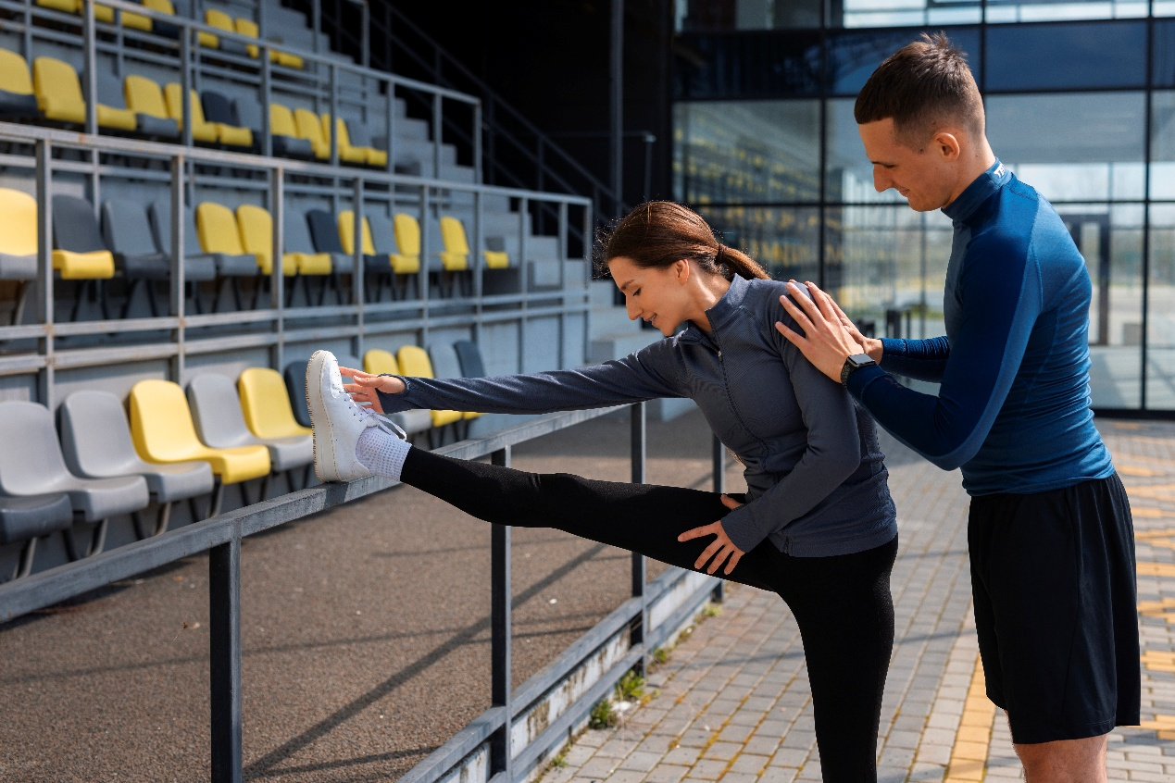

What a Personal Running Coach Brings
Hiring a private running coach flips the focus from group energy to individual progress. Imagine having a coach create a training program that is personalised to your fitness, lifestyle and goals. Pacing strategies, injury prevention strategies, all this is beautifully designed to your advantage.
One-on-one coaching is superb at tracking progress. Coaches track mileage, recovery, and performance to adjust your tailored workout schedules in real time.
This personalised feedback builds confidence and ensures you’re improving safely. For marathon preparation or competitive racing, this structured approach often produces better outcomes than group sessions.
When comparing private running coach vs group training, you’ll notice that individual coaching offers precise attention. From weekly mileage plans to race-day simulations, every session is optimised. A personalised running coaching in Australia experience often includes athlete progress tracking, helping you see tangible improvements week after week.
The cost is higher, of course. But many runners find that the investment in running coach packages and pricing is worth it for faster gains and reduced injury risk. For those unsure about committing fully, online or hybrid coaching programs offer a middle ground.


Online Coaching and Hybrid Options
The digital age has reshaped running training. Online running coaching plans bring the expertise of a personal coach to your screen, no matter where you live in Australia. Platforms like SportCoaching Australia review highlight programs that combine virtual sessions, sports science coaching methods, and performance tracking.
Hybrid models, mixing online guidance with occasional in-person check-ins, offer flexibility and accountability. Online running coach vs local club Australia comparisons show that hybrid training can match or exceed group club results while keeping costs manageable.
Runners benefit from virtual training sessions, personalised training plans, and expert oversight without sacrificing community motivation.
Even marathon training can adapt to this model. With marathon training coach vs running group frameworks, runners gain the precision of a personal coach with the camaraderie of club events.

Key Factors That Influence Results
When deciding between a running coach versus a running club comparison, several factors come into play. First, your goals: are you running for fun, endurance, or competition? Second, your budget and willingness to invest in performance coaching. Third, your need for flexibility versus routine social interaction.
Performance outcomes vary: personal coaches focus on pacing, form, and targeted workouts, while clubs provide general structure and motivation.
Competitive race coaching often requires a one-on-one approach, while clubs excel at keeping beginners consistent and motivated.
The other significant factors include injury prevention, customised pacing, and accountability. Personalised coaching is more likely to maximise gains sooner, whether you are in race preparation or trying to add momentum.
Even beginners will find alternatives, such as beginner running training programs. A structured program that balances performance and safety is available. Flexibility and guidance can be the reasons why a runner with a hectic schedule quits or attains their goals.

How to Decide What’s Right for You
Your choice comes down to personality, schedule, and goals:
If you love social energy, stick with a local running club for support and motivation.
If you want faster improvement and tailored guidance, a running coach or online running coaching plans are more effective.
Can’t pick just one? Many runners combine both: they join club runs for energy and follow a coach’s plan for progress. This hybrid approach blends accountability, coaching, and performance optimisation.


Conclusion
Clubs give you community, motivation, and consistency. Costs are low. Personal coaches watch your progress, give individual training plans, and guide you one-on-one. That often speeds things up.
Hybrid and online coaching, like SportCoaching Australia, mixes both approaches. Flexible. Customised. You can see real results.
Visit SportCoaching Australia if you are serious about improving your running and need professional guidance. They provide professional training, training programs, and performance feedback to ensure that you can reach your running objectives safely and efficiently.

